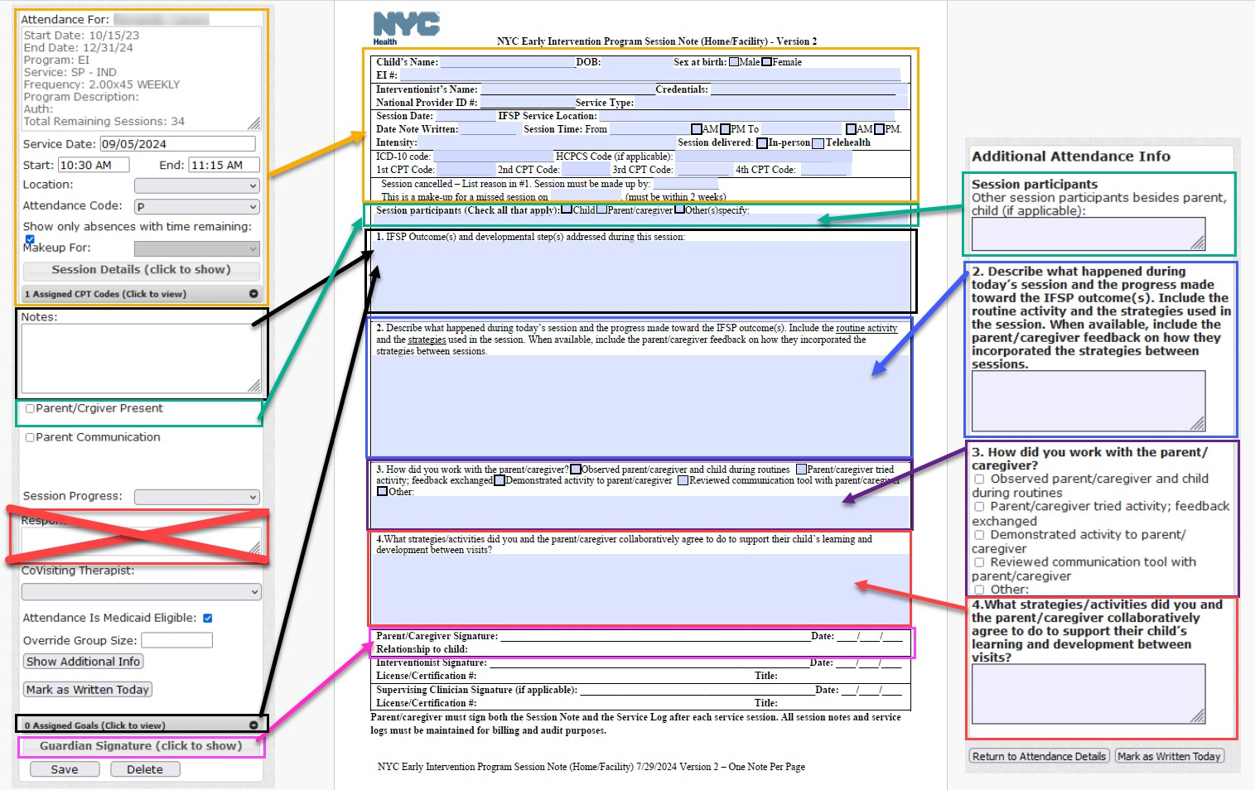Individual NYC EI Session Note Mapping

*Please see additional information below*

**\***A**\***d**\***d**\***i**\***ti**\***o**\***n**\***a**\***l **\***IN**\***F**\***O**\*\***R**\***M**\*\***A**\***T**\***IO**\*\***N**\***O**\*\***N**\***T**\***H**\*\***E**\***“**\***N**\***o**\***t**\***e**\***s**\***”**\***s**\***e**\***c**\***ti**\***o**\***n**\***i**\***n**\***E**\***n**\***t**\***e**\***r**\***c**\***la**\***i**\***m**\***s**\***:

For Cancelled Sessions: explanation/reason for absence- child sick, family had an appt, therapist on vacation, therapist sick, family did not answer door etc. For present sessions with tech issues- use P2 and explain

For present sessions- add any other relevant information about the session that you could not fit into sections 2, 3 or 4